**Practice Project**

**MVC Application**

**Aim:**

To Create an MVC Application to Manage Data for School Application.

**Github link:**

[**https://github.com/Sukirthalakshmanan1/MVC**](https://github.com/Sukirthalakshmanan1/MVC)

**Procedure:**

* Create an ASP.NET Web application =>MVC application
* Create three class Library BAL(Business Access Logic layer),DAL,Helper classes.
* BAL class has the properties of the class and their validations
* DAL class has the logic to access the data from the database
* Helper class is used as an extra layer over DAL to hide the details of the logic
* Add Business Reference to DAL and Helper.
* Add DAL reference to Helper.
* Add Helper reference to MVC Application.
* Build the solution and set the dependencies.
* MVC depends on BAL and Helper
* Data Acccess Library depends on BLL
* Helper depends on BLL and DAL
* In Web config add the connection string to the database
* Create tables student,subjects,class
* And perform Insert,update,delete,search and details operation in the DAL class
* Update ,delete,and find the table using stored procedures.
* Create a model StudModel,submodel,classmodel
* Create a controller class
* Create views for Create,delete,details,Edit and list
* And run all

**Stored procedures:**

**Subjects:**

**Update:**

CREATE PROCEDURE [dbo].[Updatesubjects]

@p_subid int,

@p_subname varchar(20)

AS

BEGIN

UPDATE subjects SET subjects_name = @p_subname

WHERE subjects_id=@p_subid

END

**Delete:**

CREATE PROCEDURE [dbo].sp_Deletesubjects

@p_id int

AS

Delete from subjects

where subjects_id=@p_id;

RETURN 0

**Find subjects:**

Alter PROCEDURE [dbo].sp_Findsubject

@p_subid int,

@p_name varchar(50) output

AS

SELECT

@p_name=subjects_name

from subjects where subjects_id=@p_subid;

RETURN 0

**Students and class:**

--delete student

CREATE PROCEDURE [dbo].sp_Deletestudent

@p_id int

AS

Delete from student

where student_id=@p_id;

RETURN 0

--find student

Alter PROCEDURE [dbo].sp_Findstudent

@p_stuid int,@p_stuclass int output,

@p_name varchar(20) output

AS

SELECT

@p_name=student_name ,@p_stuclass=student_class

from student where student_id=@p_stuid;

RETURN 0

--find class

create PROCEDURE [dbo].sp_FindClass1

@p_stuid int,@p_stuclass int output

AS

SELECT @p_stuclass=class_strength

from Class1 where Room_no=@p_stuid;

RETURN 0

--update student table

Alter PROCEDURE [dbo].[Updatestudent]

@p_stuid int,

@p_stuname varchar(20),

@p_stuclass int

AS

BEGIN

UPDATE student SET student_name = @p_stuname,

student_class=@p_stuclass

WHERE student_id=@p_stuid

END

--update class

Create PROCEDURE [dbo].[UpdatesClass1]

@p_stuid int,

@p_stuclass int

AS

BEGIN

UPDATE Class1 SET

class_strength=@p_stuclass

WHERE Room_no=@p_stuid

END

--delete class

CREATE PROCEDURE [dbo].sp_Delete

@p_id int

AS

Delete from Class1

where Room_no=@p_id;

RETURN 0

**Output:**

**Student:**

**List of students:**

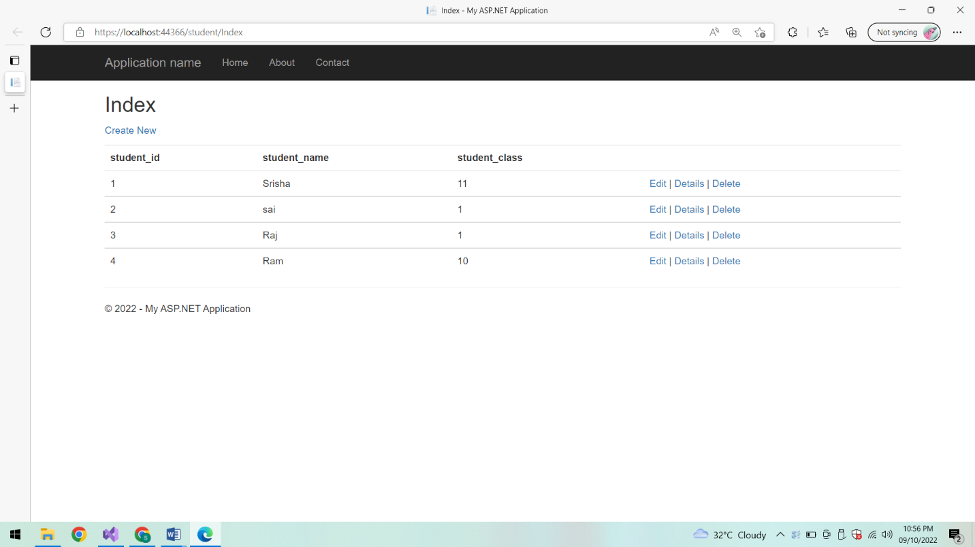

**Add a student:**

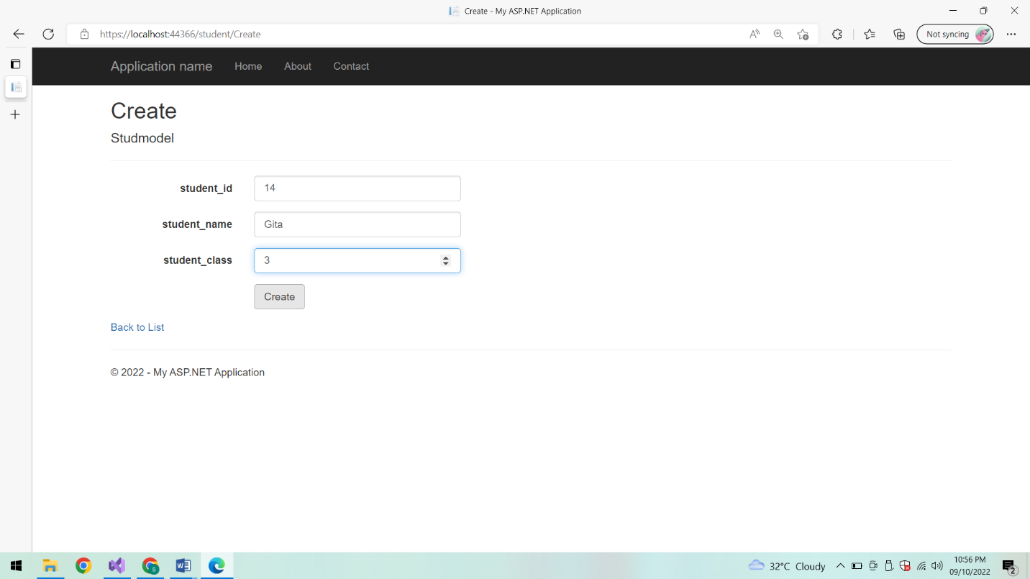

**Student added:**

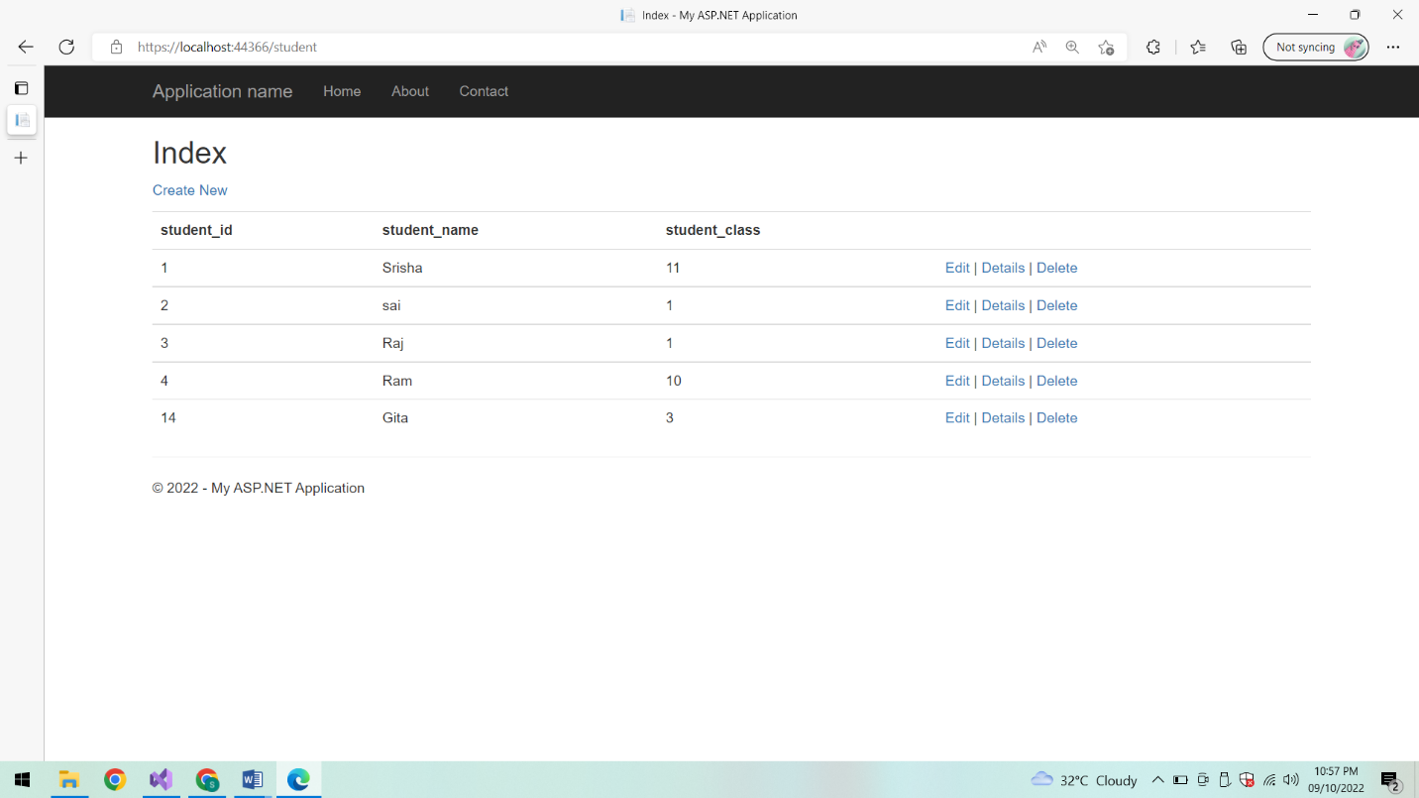

**Edit the details of student:**

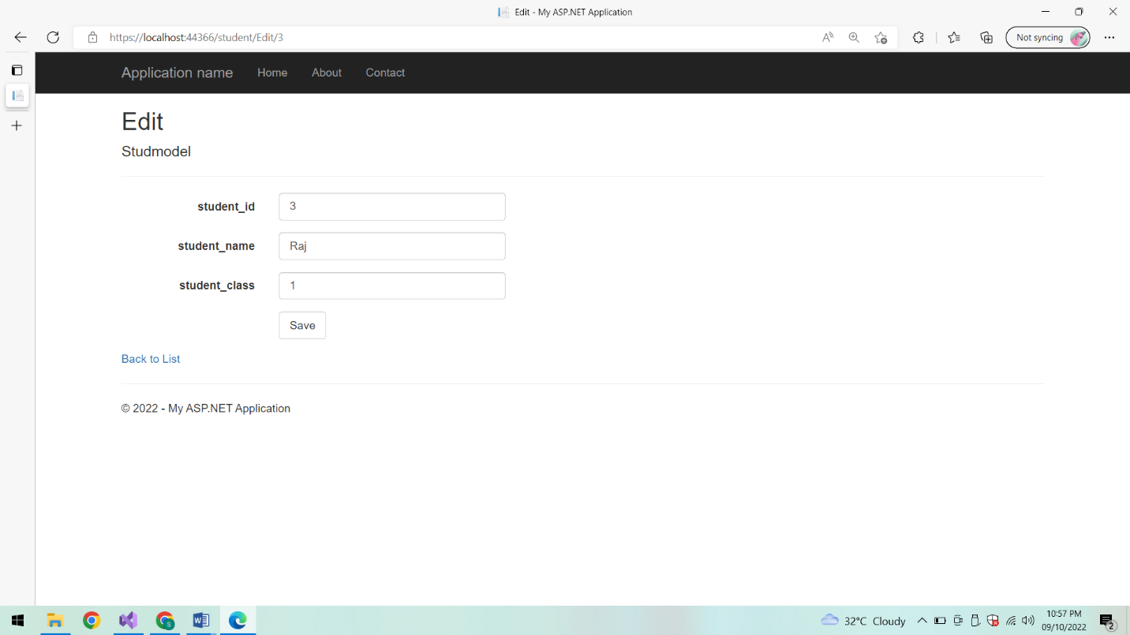

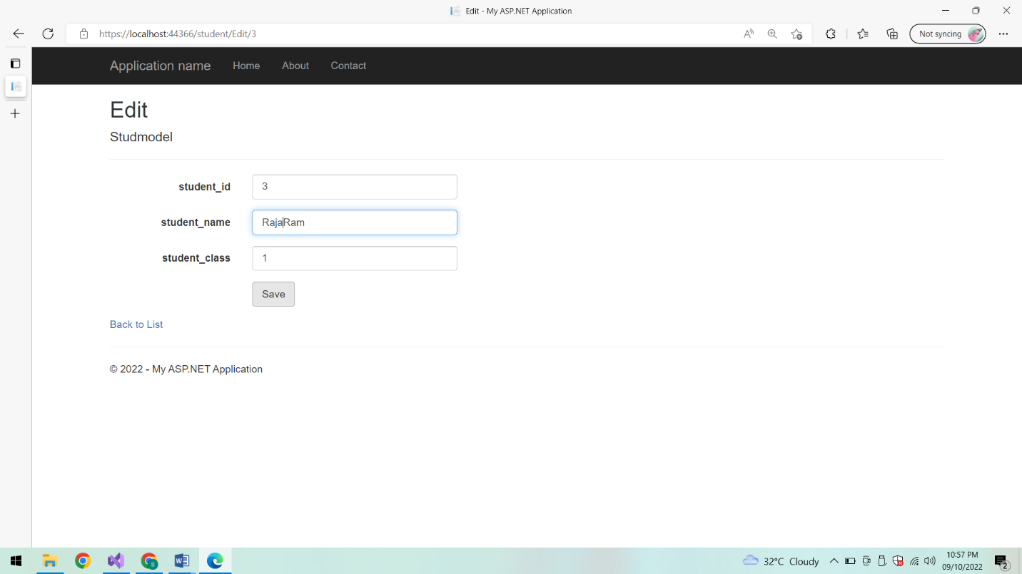

**After Editing List of students:**

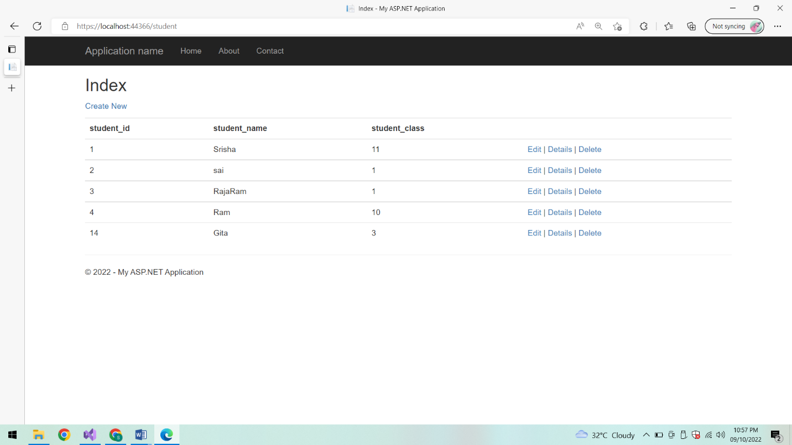

**Details of student:**

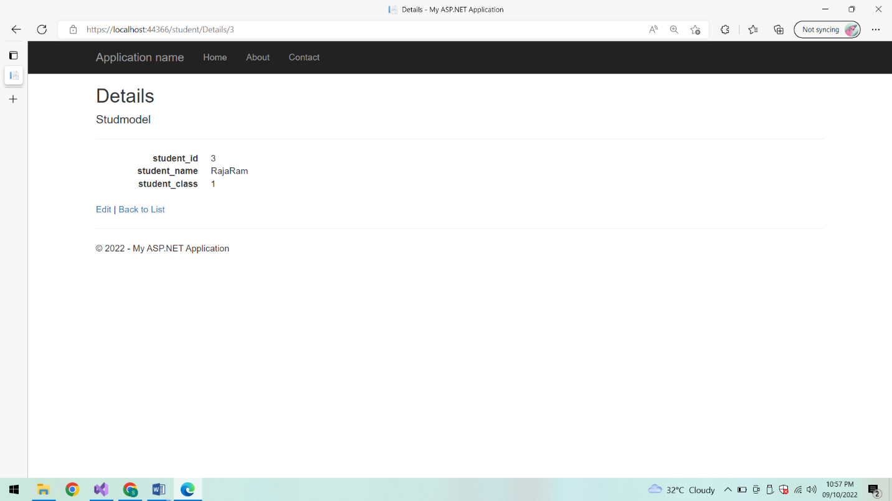

**Edit:**

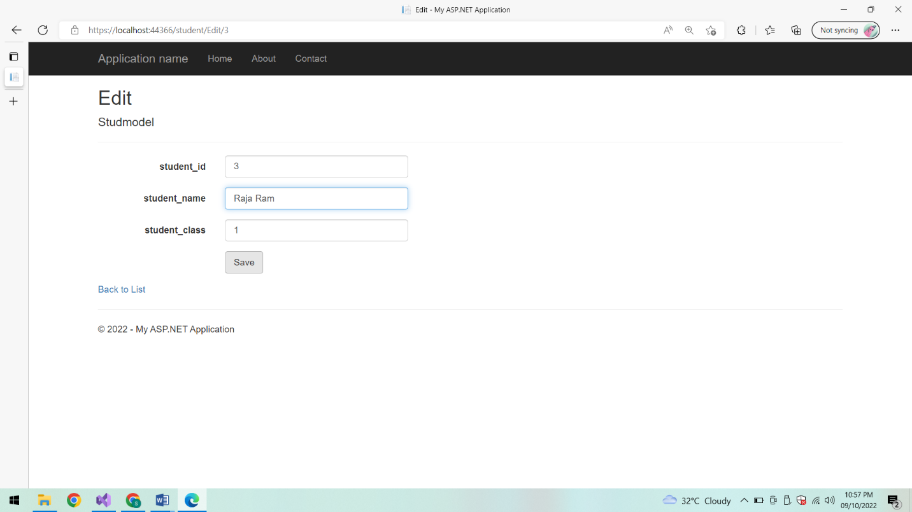

**List of students:**

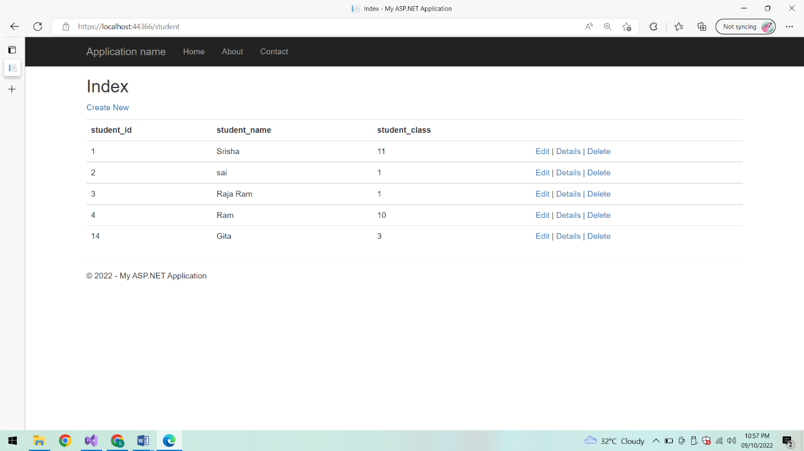

**Delete student:**

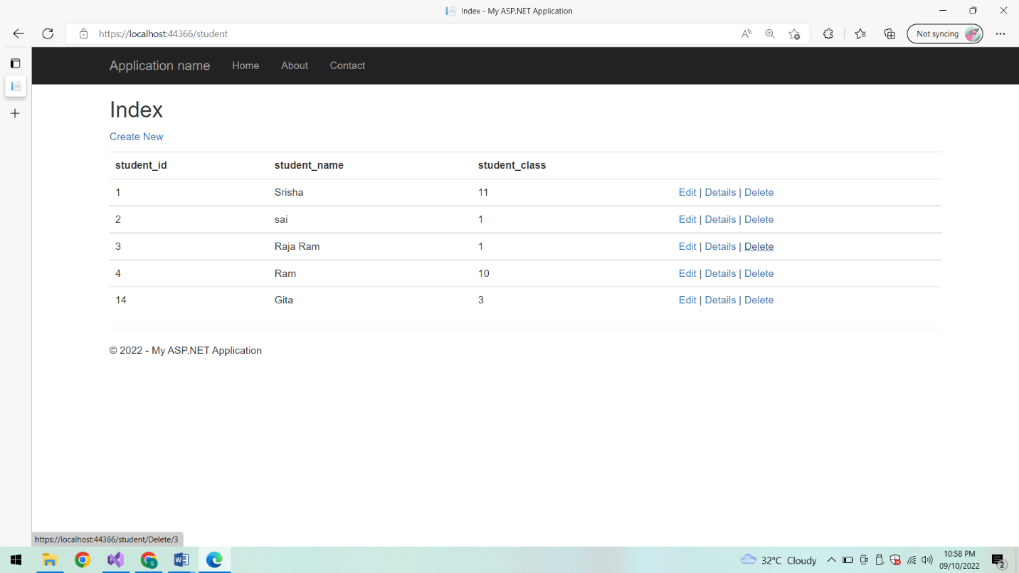

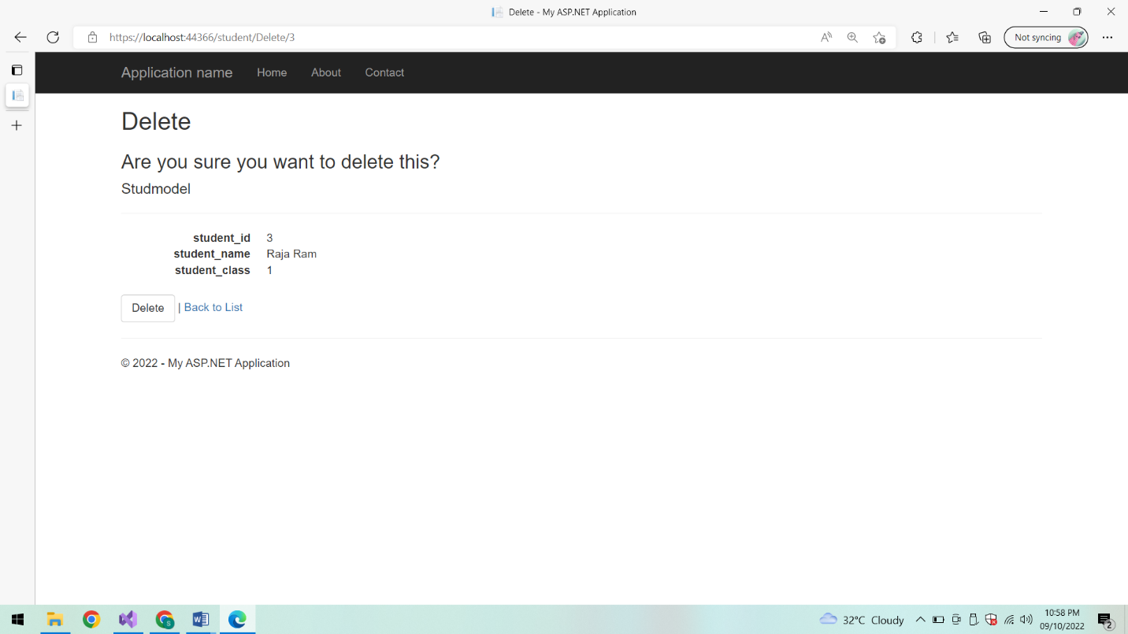

**List of students:**

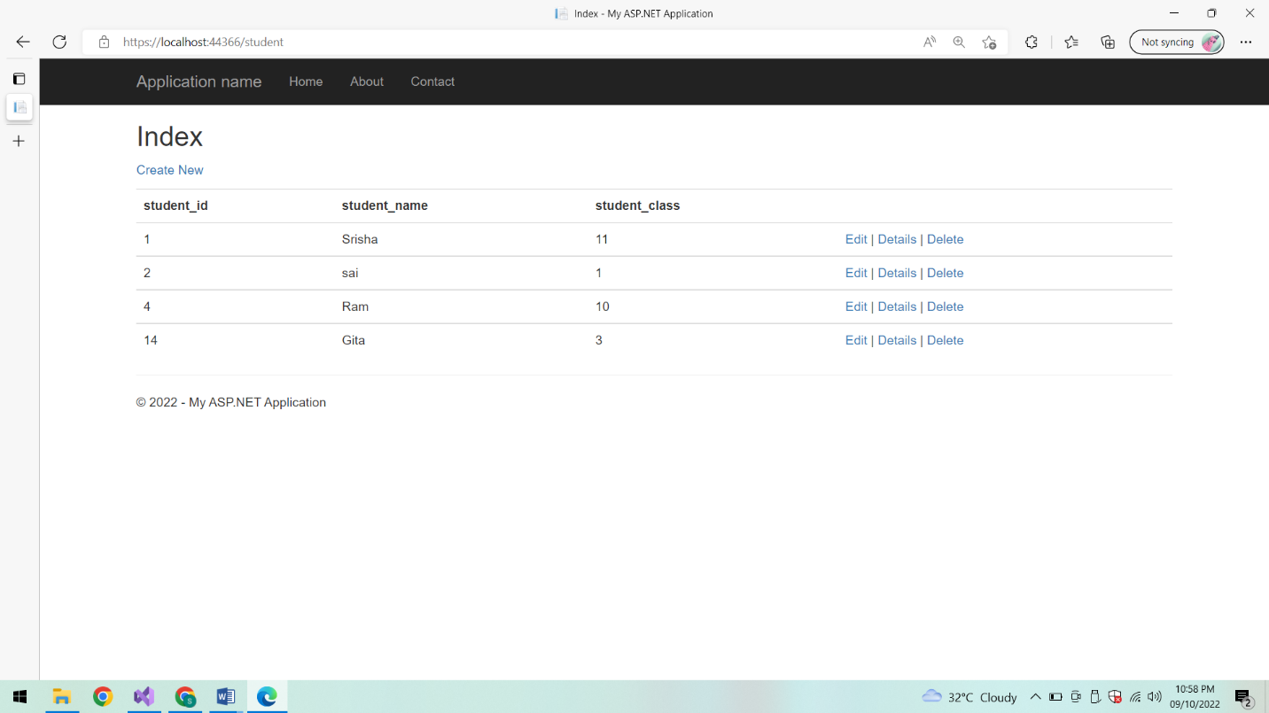

**Subjects:**

**List of subjects:**

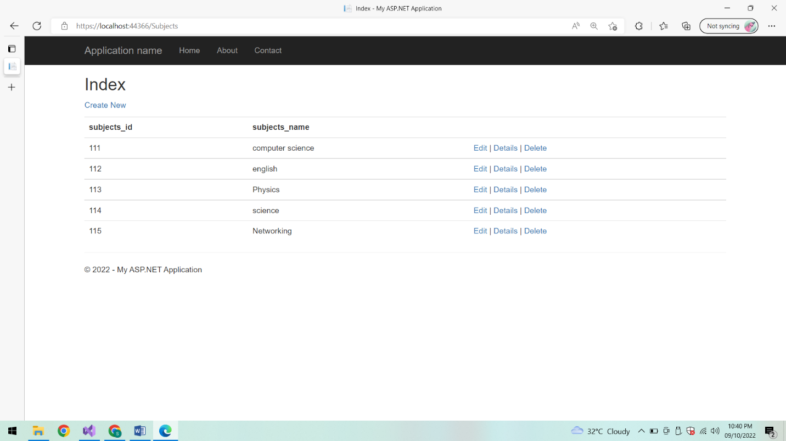

**Add subject:**

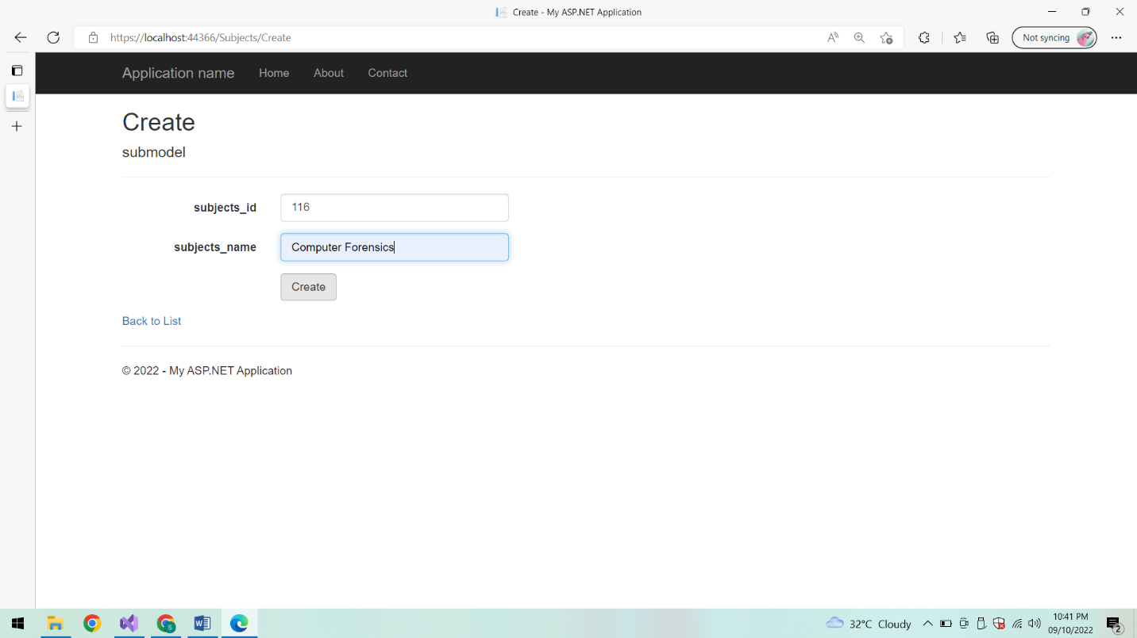

**List of subjects:**

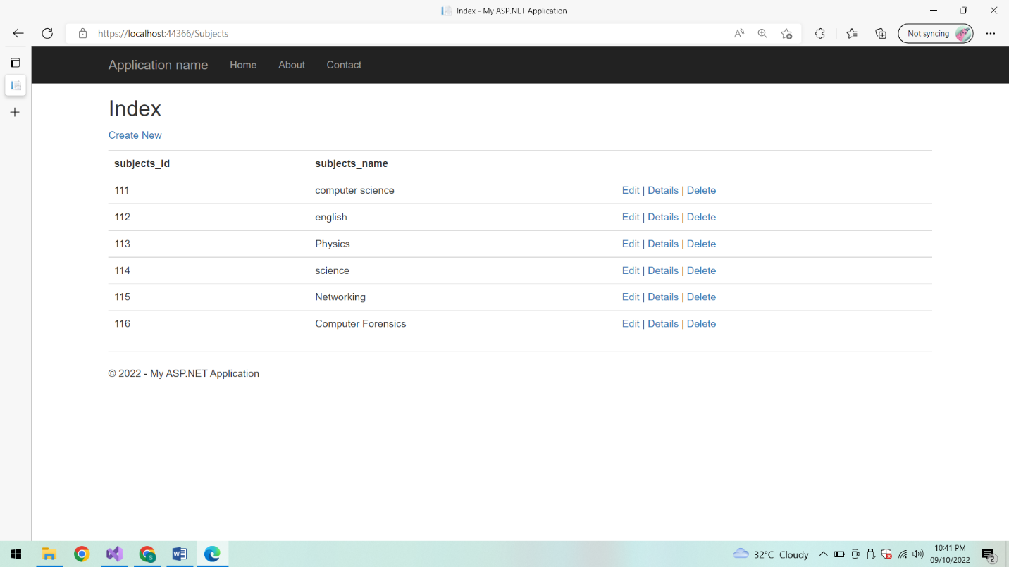

**Edit:**

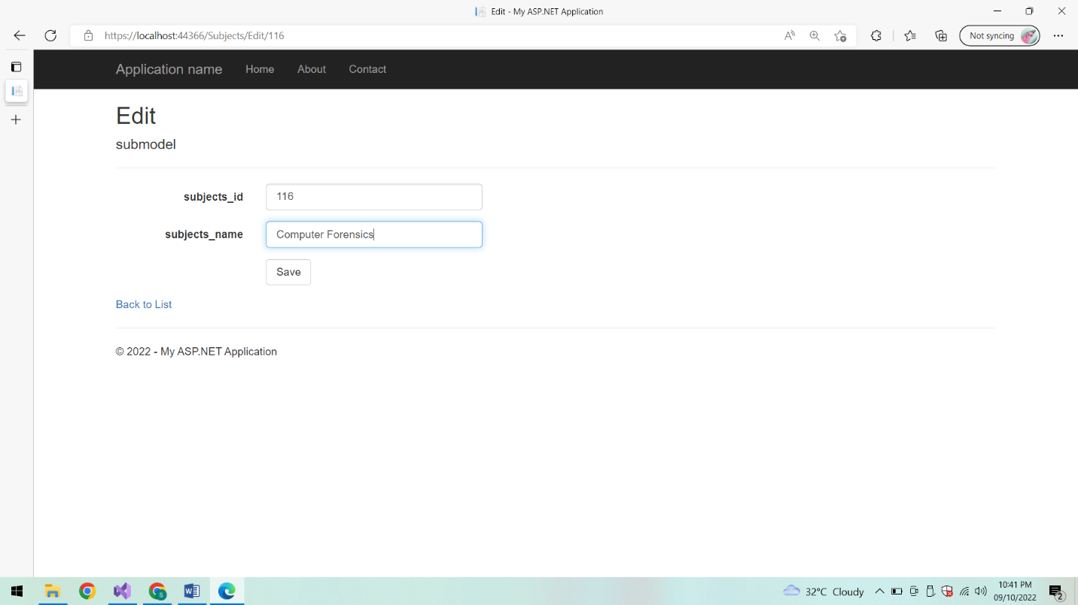

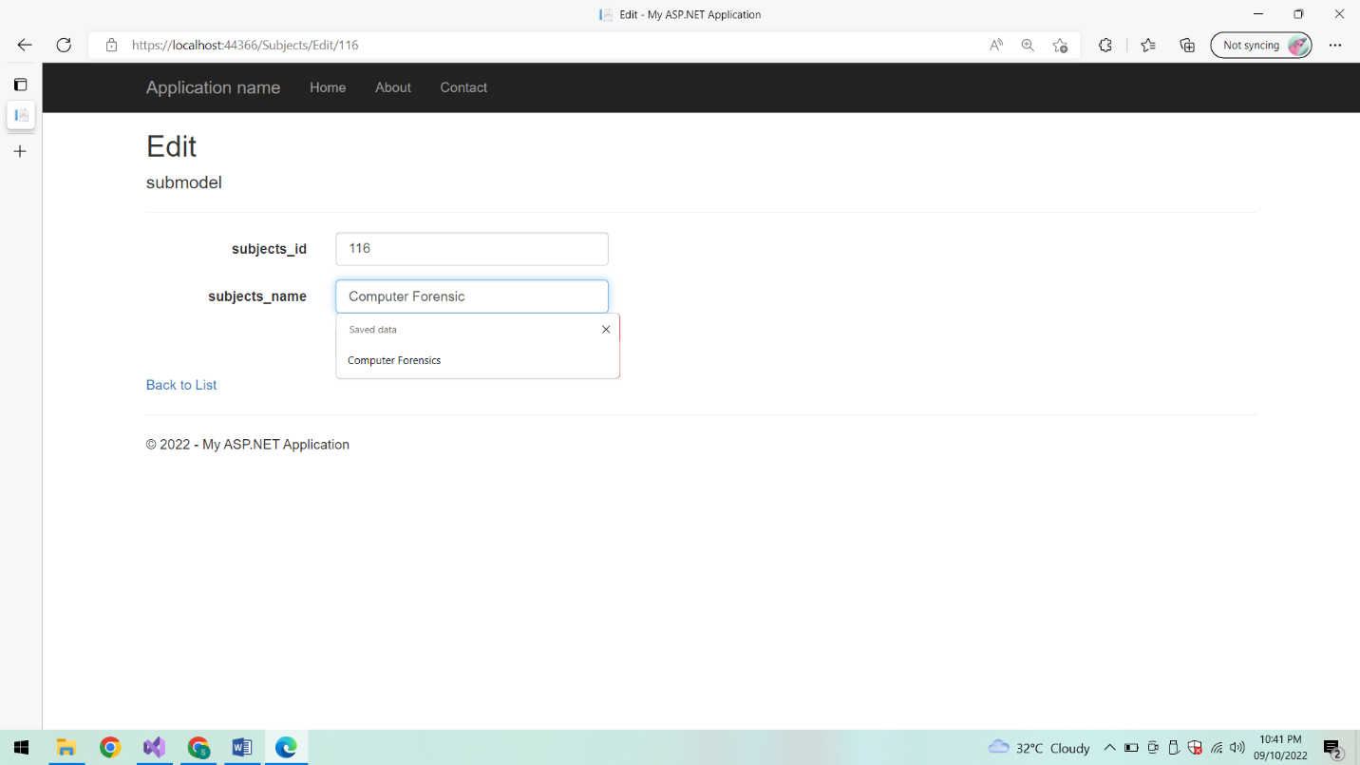

**After Editing List of subjects:**

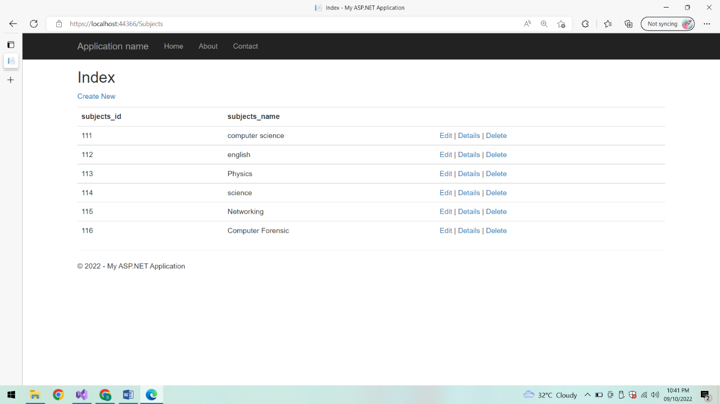

**Details:**

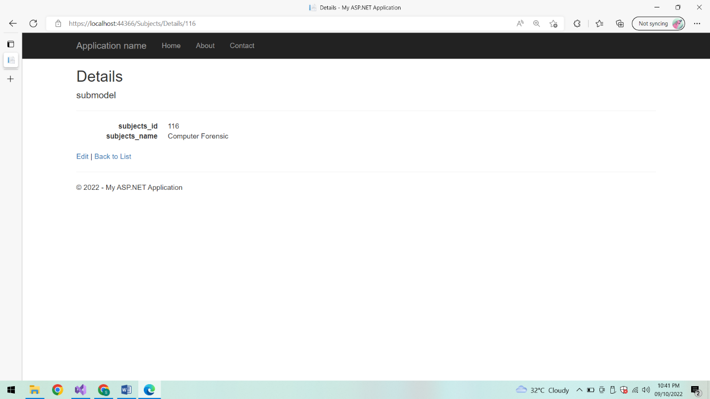

**Edit:**

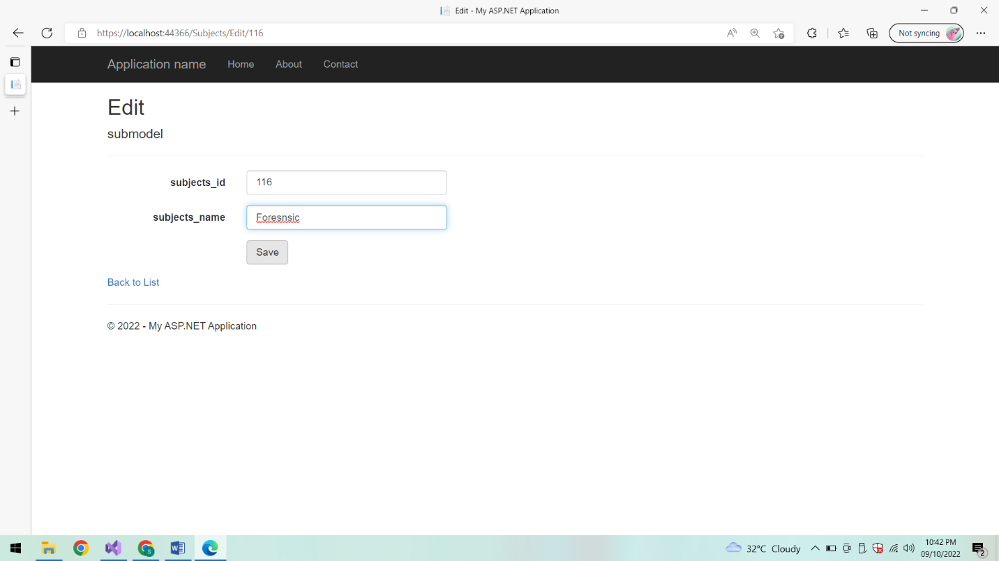

**List of subjects:**

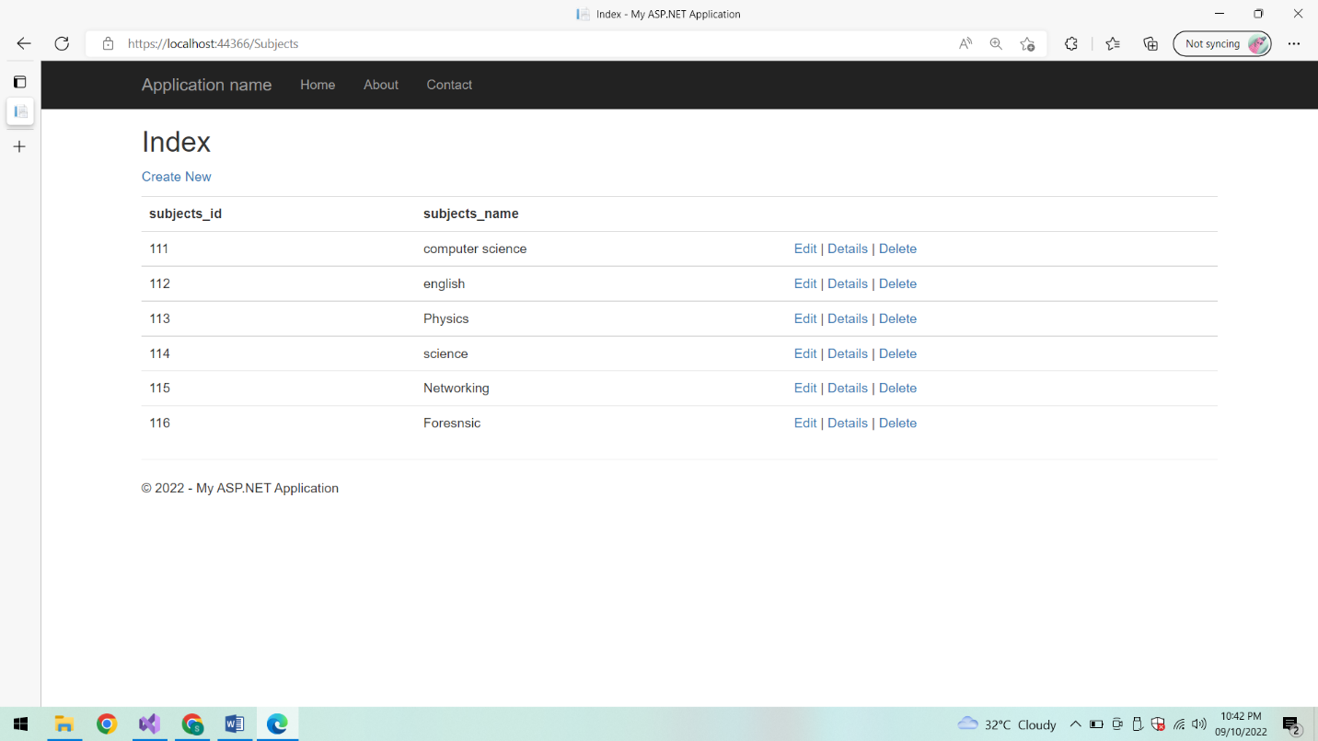

**Delete:**

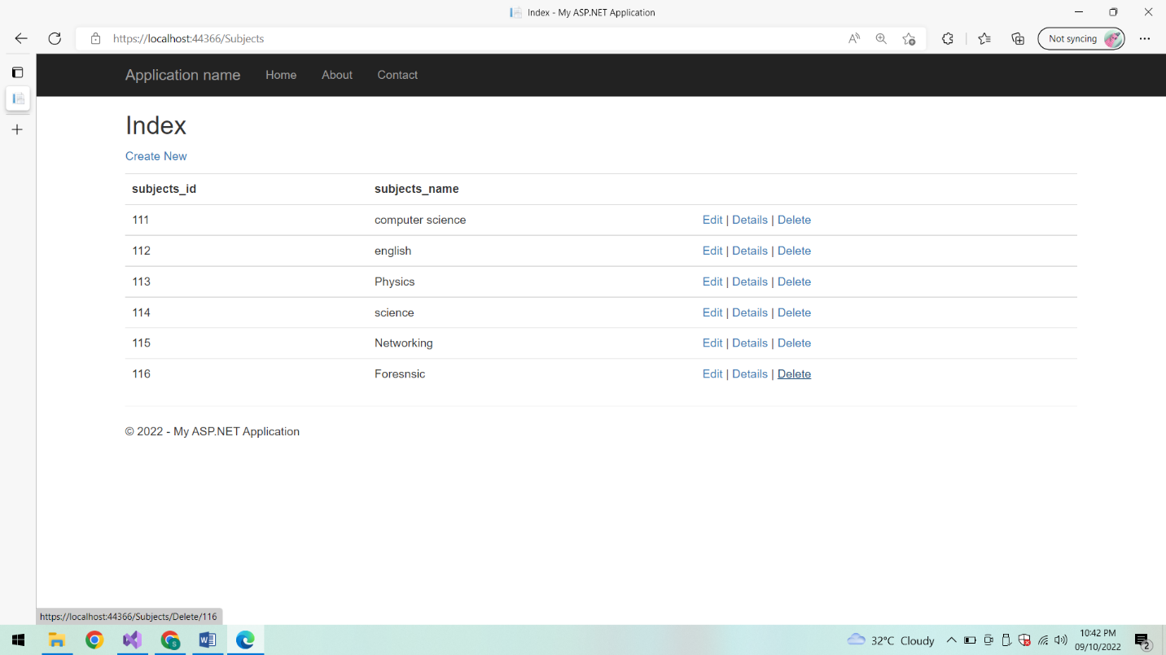

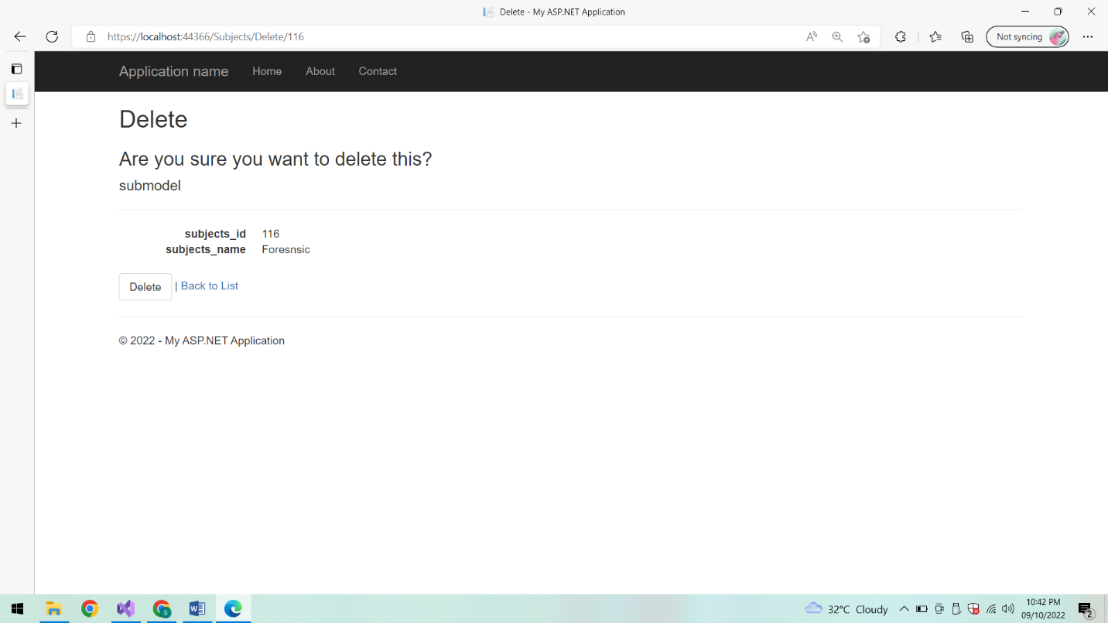

**After deletion List of subjects:**

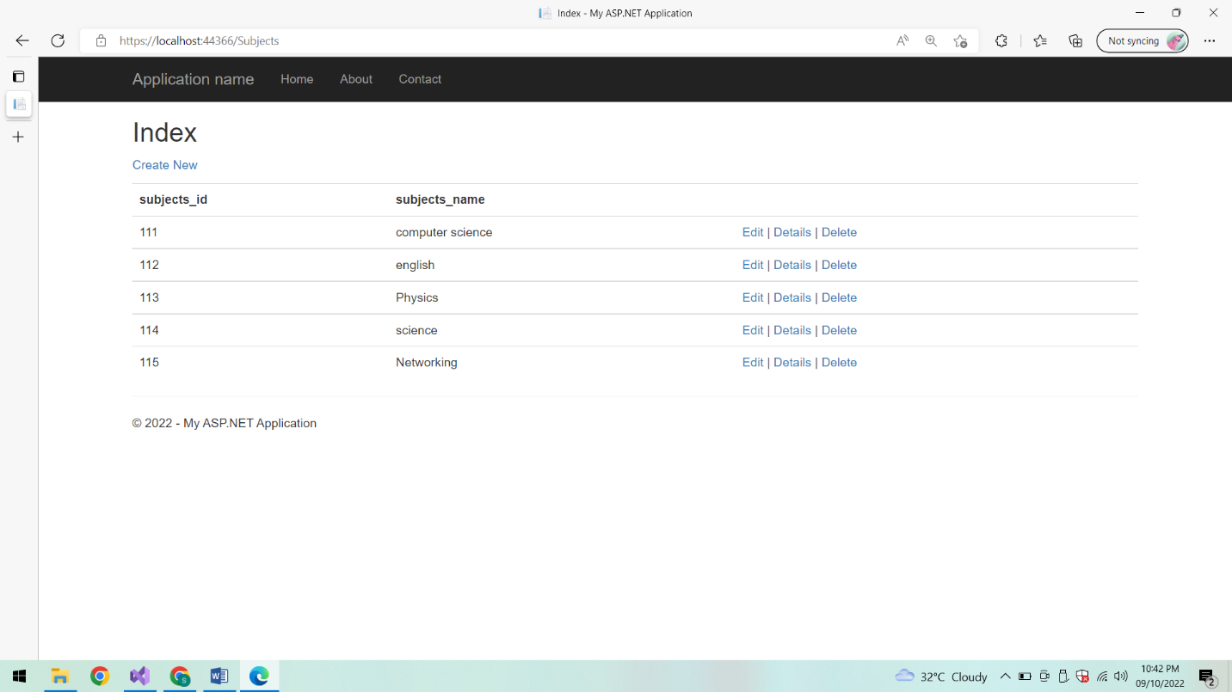

**Class:**

**List of classes:**

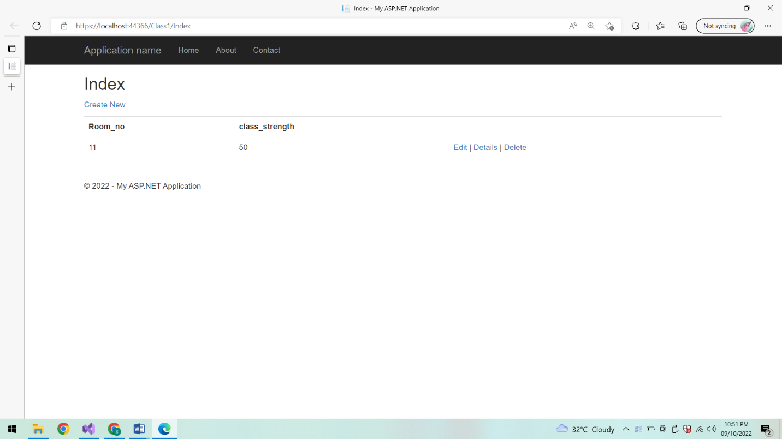

**Add a class:**

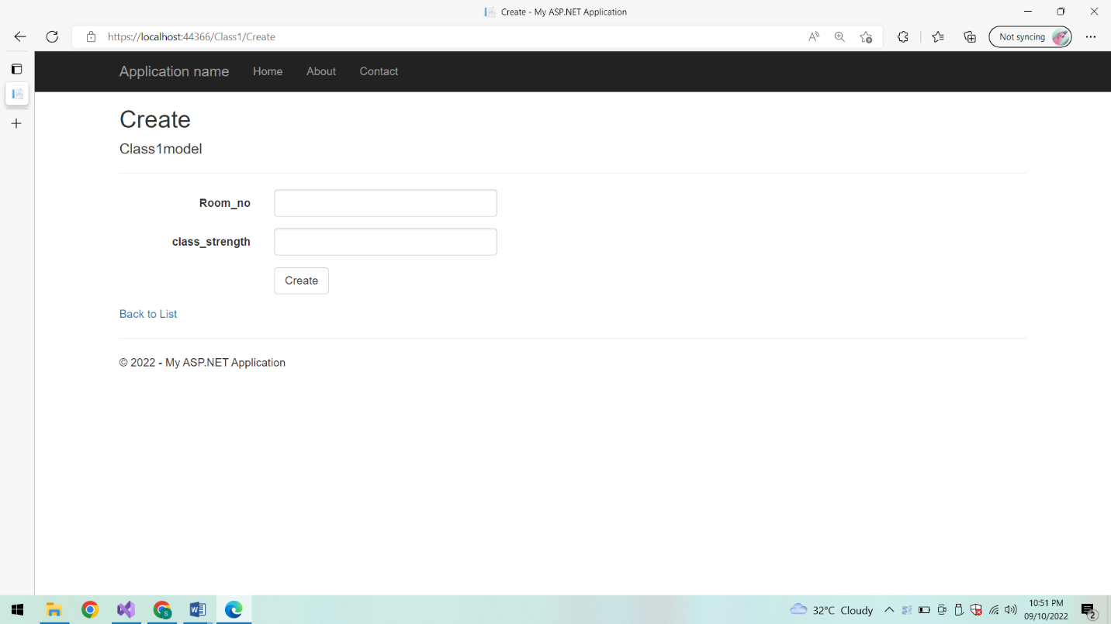

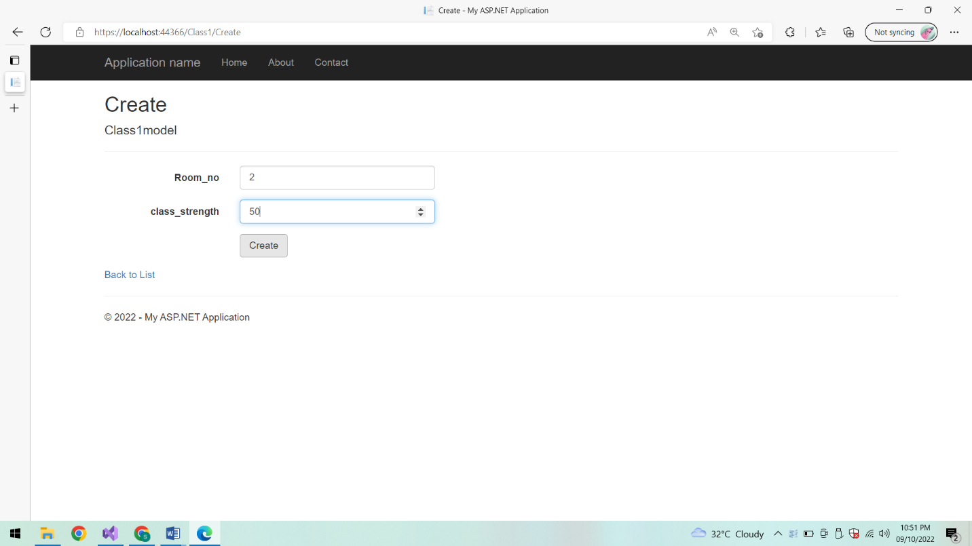

**List of Classes:**

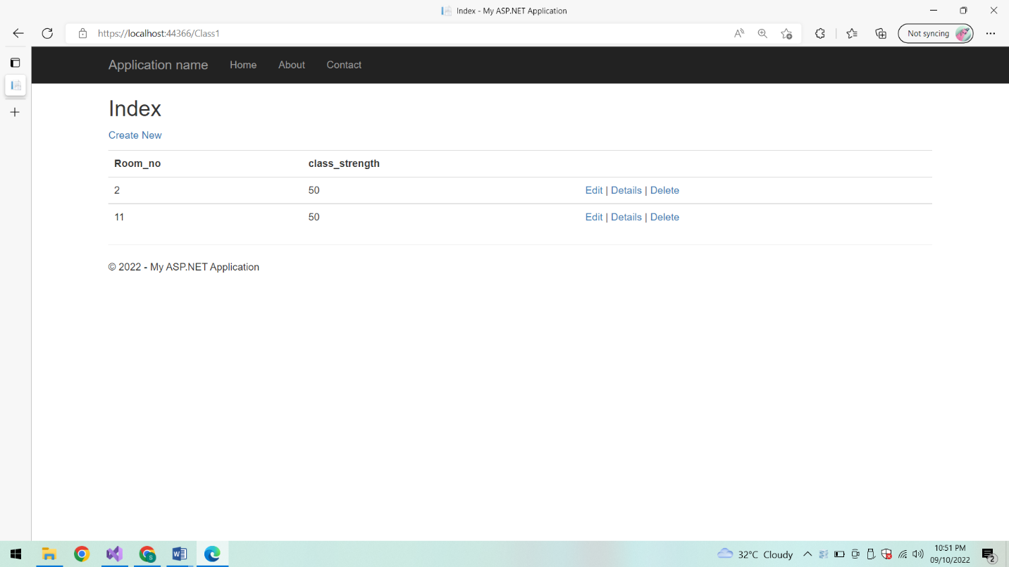

**Edit:**

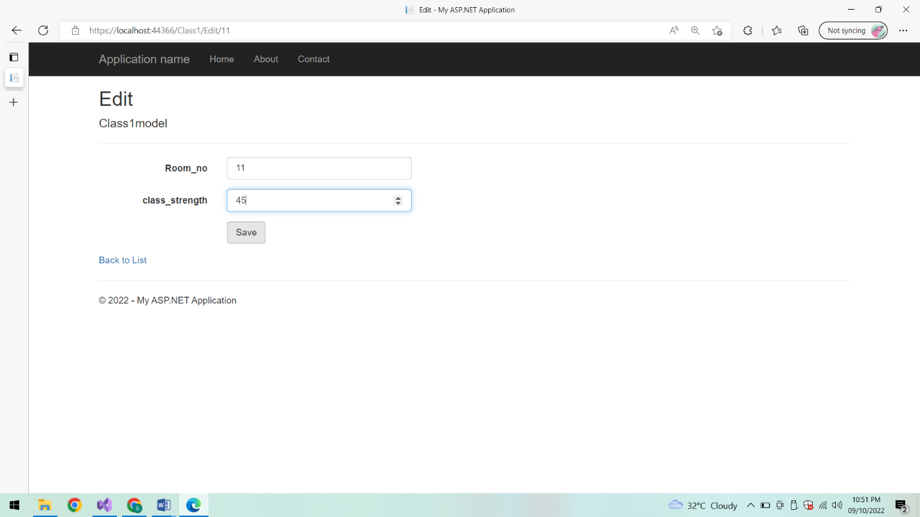

**List of classes:**

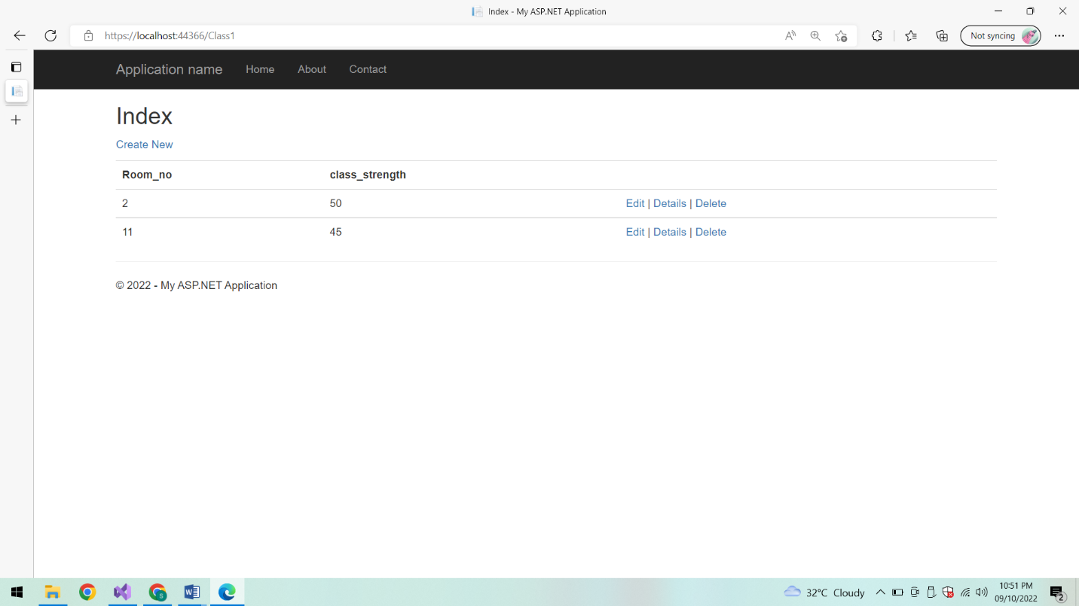

**Details:**

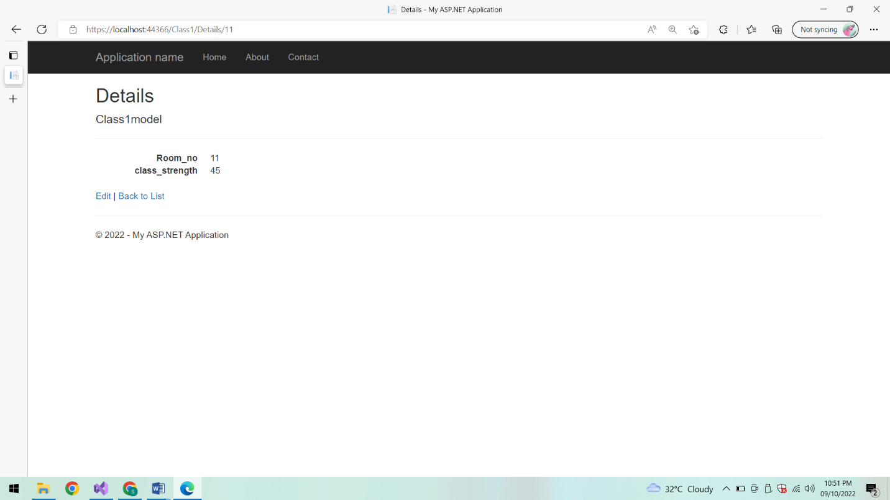

**Edit:**

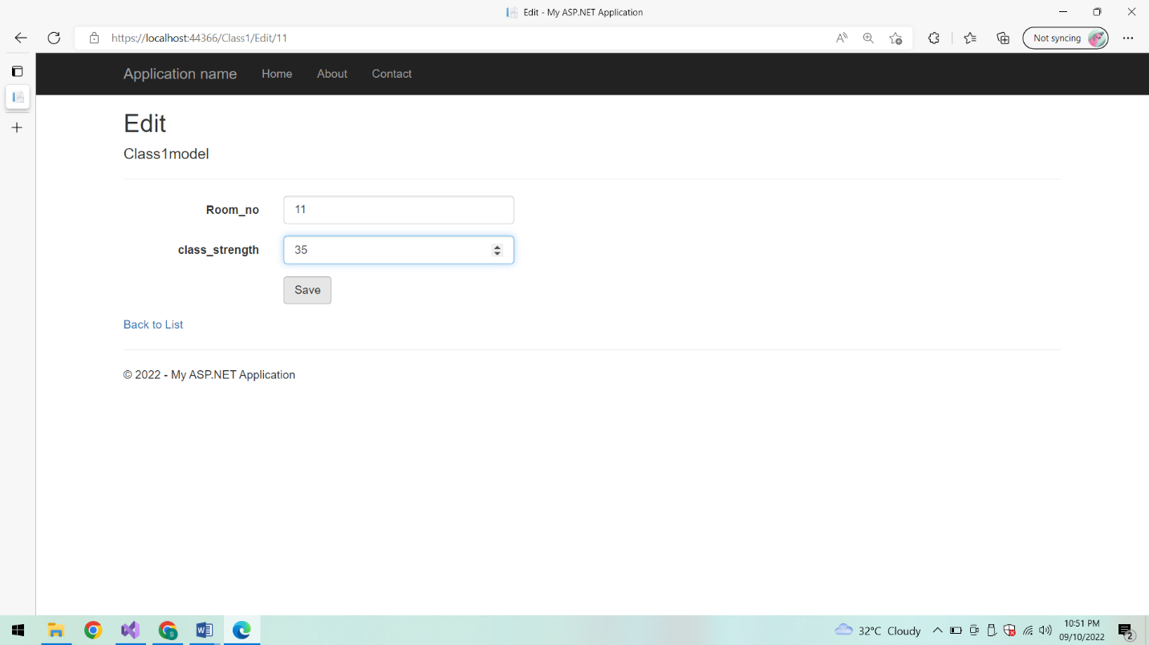

**List of classes:**

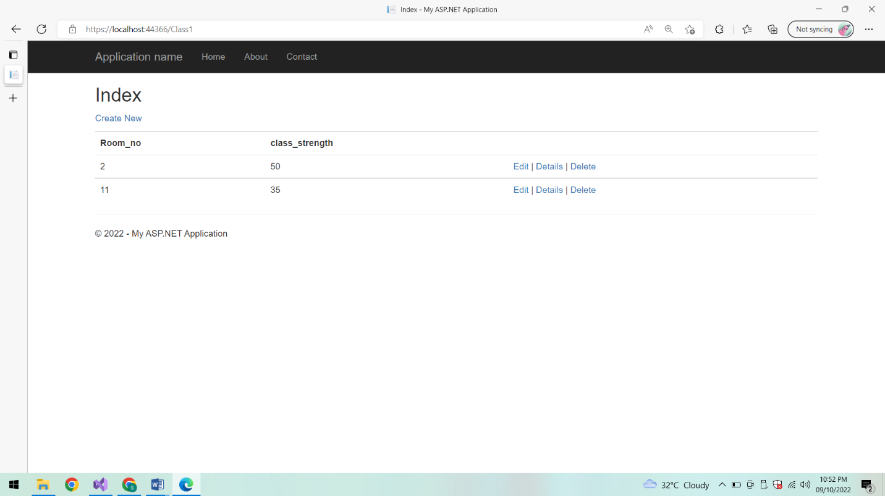

**Delete:**

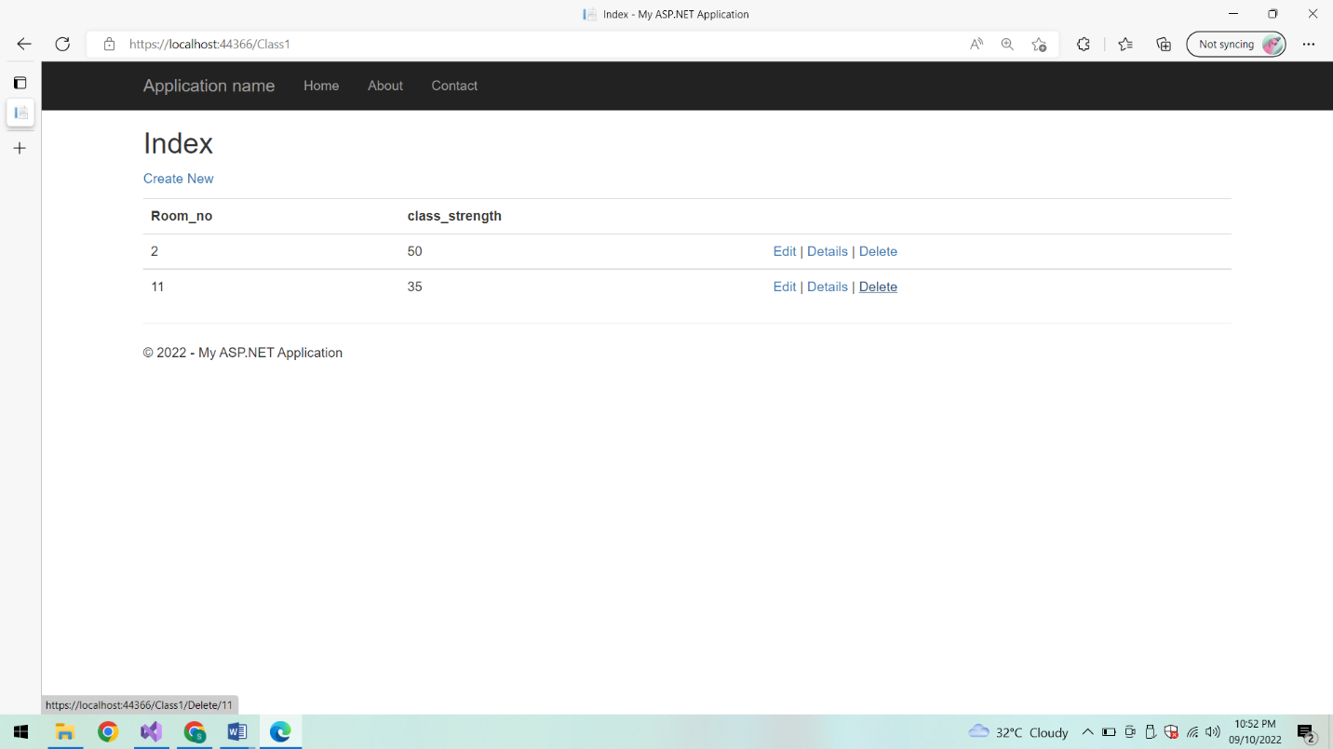

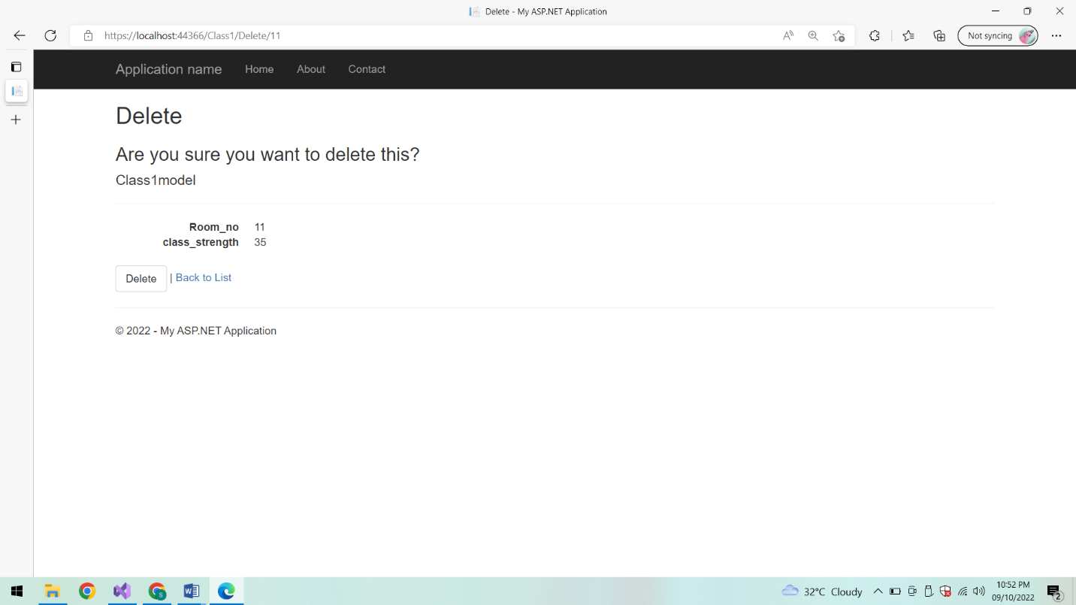

**After deletion List of classes:**

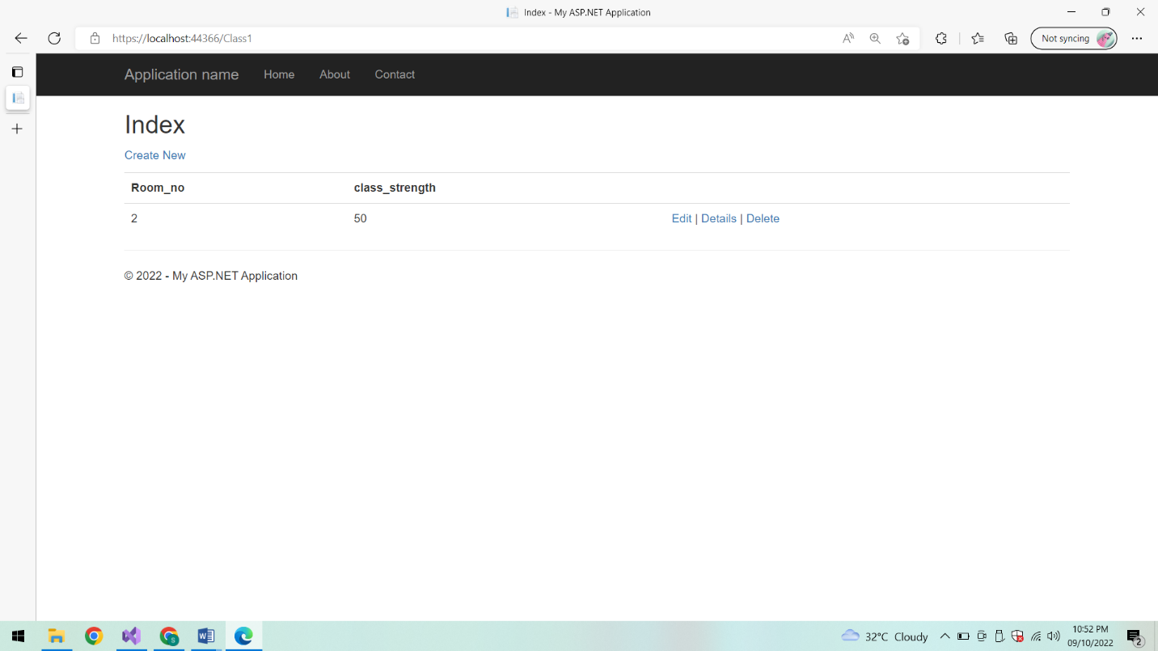

**Conclusion:**

Thus the MVC application is created successfully.